Rockman’s Catering
(715) 341-2552

2807 Plover Springs Dr.
Plover, WI 54467
www.rockmanscatering.com

Thursday, November 26, 2020
Orders must be received by 12:00pm Friday, November 20th
Take-out/Delivery ~ 10:00am to 3:00pm
“Ready-to-Heat” option available for pick-up on Wednesday, November 25th ~ 2:00pm to 6:00pm

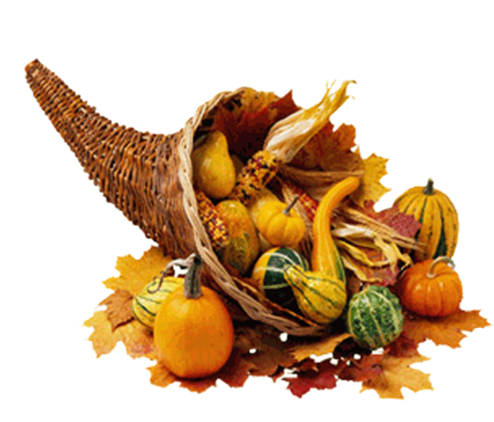
“Traditional” Menu
Herb-Butter Roast Turkey
Mashed Yukon Gold Potatoes
Stuffing
Turkey Gravy
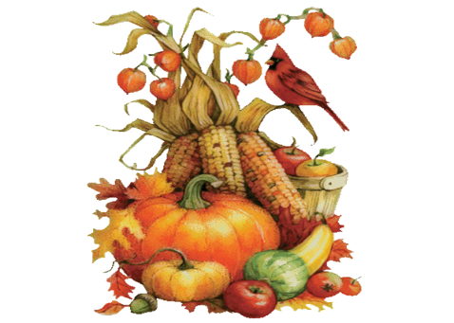
Green Bean Casserole
Honey-glazed Yams
Cranberry Relish
Garden Salad w/Ranch Dressing
Potato Clover Rolls
Pumpkin Pie

(Feeds 4-5 people – half Turkey) $120.00
(Feeds 8-10 people – whole Turkey) $210.00

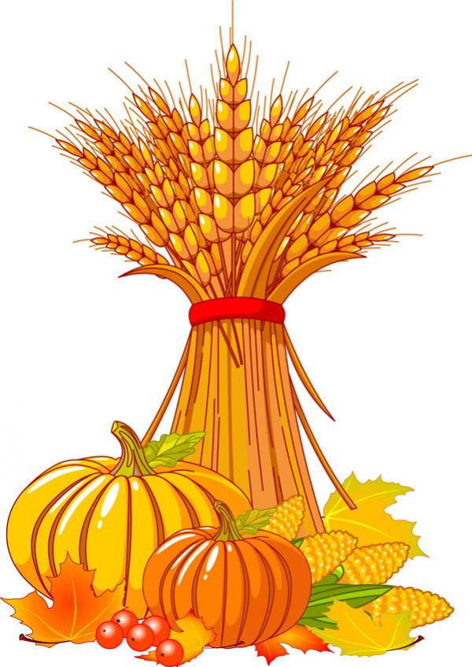
“Something Else” Menu
Herb-Butter Roast Turkey
Buttermilk Boursin Mashed Potatoes
Apple Sausage Stuffing
Gingersnap Gravy
Fried Brussels’ Sprouts w/Bacon, Craisins & Parmesan
Rum Sweet Potato Bake
Cranberry Ginger Chutney
Harvest Salad w/Balsamic Vinaigrette
Cheddar-chive Cornbread
Vermont Pumpkin Cheesecake

(Feeds 4-5 people – half Turkey) $150.00
(Feeds 8-10 people – whole Turkey) $275.00

Limited Quantities Available ~ Place Your Order Today!!!!!
* Orders must be received by Friday, November 20th – 12:00pm.
* Pre-payment by credit card please.
* Order by phone (715) 341-2552 or by email (srockman@rockmanscatering.com) or Web-site inquiry and we will call you back (you’ll need to leave us your phone number!).
* Take-out or delivery service available; add 10.00 fee for delivery.
* Tip for the driver is not included in the pricing (and we’re sure they would appreciate a little something).
* 5.5% sales tax is not included in prices.

*Prices include cloth tablecovers & napkins, china place-settings and all the needed service staff.
*Minimum 60 guests (add $1.00/person for groups under 60).
*A staff travel fee may be added to deliveries outside the Plover/Stevens Point area.
*A 17% service charge and 5.5% sales tax will be applied to all food & beverages.
*A 3% discount will apply if the invoice is paid (in full) with cash or check on or before the day of the event. rev 1/1/16

